GAD312 Readings & Assignments: Week 4

Week 4 Reading
Complete the following reading early in the week:
- Week 4 online lectures
- The following sections from the text, Andrew Rollings and Ernest Adams on Game Design:
  - Chapter 8: The Internal Economy of Games and Game Balancing
  - Chapter 14: Construction and Management Simulations
- The Web page:
  - http://www.gamasutra.com/features/20020104/adams_01.htm
Note: While reading, make notes of pertinent and important facts. You will be required to reference your readings in discussions and apply them in the week's assignments.
Week 4 Assignments Overview
Assignment Summary: Week 4 | Due Date
Assignment 1: Discussion Questions | Week 4, Day 3
Assignment 2: Identifying the Dominant Strategy | Week 4, Day 3
Assignment 3: Setting up Probabilities | Week 4, Day 5
Assignment 4: Hit Point Charting | Week 4, Day 5
Assignment 5: Final Project—Defining the Core Mechanics | Week 4, Day 7
Remember that all assignment details can be found on the assignment pages located throughout the week. Go to those specific pages for direction on how to complete each individual assignment.

Week 4 Overview
The last three weeks have brought you a long way into the discipline of game design. Last week you learned to create the appropriate user interface for both PC and console games. You also learned about level design and how you can implement it in your game. Now that you have learned about the basics of creating a game, the next step is to learn how you can enliven the gamer's experience by making your game more true to its setting and give the players a sense of fairness. The focus of this week is on understanding and implementing the core mechanics of your game. You will learn to define the core mechanics for your game and then fine tune or balance them to enhance gameplay. You'll learn about balancing your game to make it more playable.

Learning Outcomes:
Analyze games based on game theory and strategy.

Core Mechanics

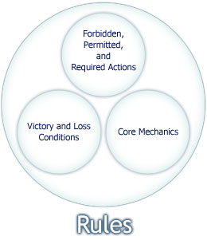
What Defines Core Mechanics?
Every game has rules. If a form of interactive entertainment doesn't have any rules, it's more of a toy than a game. The rules define several things for the players and usually form the following three sets:
- Which actions do they need to take and which actions are optional?
- How will they win, lose, or tie the game?
- How does the the game work? What happens on a moment-by-moment basis, including internal events not directly caused by the players (such as the passage of time)?
In a videogame, the actions that the player takes are typically controlled by the user interface, so it's not necessary to make them explicit. For example, in most war games, it is forbidden to intentionally target your own troops. In a war board game, this would be explicitly stated in the rules; in a videogame, it's simply not available as an option.
The second set of rules that defines how players win or lose a game comprises special rules called “completion conditions,” which are usually either victory conditions or loss conditions. We've already discussed these conditions last week. The third set of rules tells us how the game works and defines the core mechanics, or the fundamental principles and processes of the game.
The core mechanics are independent of the appearance of a game. If the mechanics work well, then the player may sense that there is a quality of elegance in the game. However for the most part, the mechanics don't contribute in a direct way the game's look and sound. It's possible for two games to have identical core mechanics but completely different graphics and audio. In fact, in the 1980s, some game publishers became notorious for turning out “cloned” side-scrolling games—games that were functionally identical to one another. The settings were different but the core mechanics were the same. After a while players began to realize that they were being sold essentially the same game in a different skin and quit buying them.
The core mechanics also help to create some of the challenges in a game. For example, the primary challenge in most roleplaying games is to raise the avatar's number of experience points. The core mechanics define what experience points are, how players get them, and what happens when they pass certain thresholds. There are exceptions—the exploration challenge of learning your way around an unfamiliar space is created not by the core mechanics but by the setting. But for the most part, the core mechanics are closely related to a game's challenges.

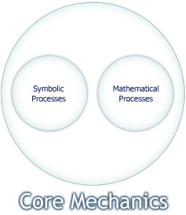
The Types of Core Mechanics
Core mechanics can be divided into two types:
- Symbolic processes
- Mathematical processes (or models)

Symbolic Processes
A symbolic process is a game mechanism that operates without reference to numbers. In a purely symbolic game, symbolic activities matter much more than manipulation of numbers. For example, chess is a symbolic game. Although it is true that each player starts with eight pawns, two rooks, two knights, and so on, the numbers of these pieces don't really matter much. The victory condition in chess is not defined in numeric terms: it's about checkmating the king, not taking the most pieces. It's perfectly possible for the player with fewer pieces to win the game. What matters most is how the pieces are positioned on the board, how they move, and how they control space—purely symbolic concepts. Again in the Dungeons & Dragons RPG games, character alignment (a combination of the character's attitude towards good and evil and his attitude towards lawful, i.e. organized and predictable behavior versus chaotic behavior), is a symbolic quality without a distinct mathematical model.
Monopoly on the other hand has relatively few purely symbolic activities. Almost all of its mechanics are concerned with the movement of amounts of money—a mathematical process. Just about the only symbolic action in Monopoly is going to jail, which moves the player's piece on the board but doesn't cause money to change hands. (However the player may pay money or roll dice to get back out again and those are mathematical processes.) Similarly a shooter game has almost no symbolic processes. If the game includes locked doors and keys then the relationship between the keys and the doors is a symbolic one; but for the most part, shooter games are controlled by numbers: amounts of ammunition, rate of fire, weapons accuracy, health, and so on.

Mathematical Processes
Mathematical processes on the other hand, are all about numbers; in particular, amounts of things and the way those amounts change in response to events in the game. These can be either player actions or internal events such as the passage of time. A flight simulator includes many mathematical processes. The behavior of the weather and also the behavior of the plane are all simulated mathematically. Airplanes are subject to four classic forces: lift, gravity, thrust, and drag. These forces act on the airplanes to push them up, down, forwards, and backwards respectively. The mathematical interactions among these forces (along with many more subtle qualities) determine how the plane flies. Different flight simulators simulate these interactions with greater and lesser degrees of accuracy. The software that simulates this model is called the physics engine and its behavior is defined by the core mechanics.
Many games have hybrid core mechanics—they include both mathematical and symbolic elements. Poker is a good example of this. The value of the different possible hands is determined by the laws of probability. A royal flush is higher than an ordinary flush because it occurs less frequently, a mathematical relationship. But the relationship among the individual ranks of the cards is a symbolic one. (There is no particular reason why a jack should be higher than a 10; it's just defined that way and in many games it's necessary to specify whether an ace is high or low.) The assignment of a given card to be “wild” is also a symbolic one.

Internal Economy
In the last section, we saw that the behavior of a physical system like an airplane is defined by its mathematical model. But a much more common kind of mathematical model is the internal economy—a system that controls the flow of resources in a game. When we think of resources, we tend most often to think of tangible items like money and goods. But in fact a resource can be anything of significance or value as long as it can be quantified—measured or counted. When we work for pay, we trade our labor (an intangible resource) for money (a tangible one).
Here are some classic resources found in videogames:
- Health, usually measured as hit points
- Lives (more common in older videogames)
- Money
- Ammunition
- Fuel
- Population (of computer-controlled people or creatures)
- Speed or velocity
- Acceleration
- Weight of people or vehicles
- Happiness or contentment

It's worthwhile to remember that not every resource is a good thing. In the original Sim City, pollution and crime were resources created in industrial parts of town. These were resources the player tried to minimize rather than maximize.

The behavior of such game resources is often governed by parameters, which are additional numeric values that either set limits on the variability of the resources, or have an effect on the rate of change of some resource or another. Consider an artillery gun in a fixed location. Among its parameters are the following:
- Rate of fire or the number of times per minute that it can shoot. This determines how quickly it depletes its ammunition.
- Range or the maximum distance at which it can hit something. If an enemy is out of range, the gun doesn't shoot at it.
- Accuracy or the probability of its hitting something. This is usually not a single number, but a value that is reduced in proportion to the range.
- Power or the destructive capacity of its shells.

The parameters also depend on the object to which they apply. For example, if we consider a tank instead of an artillery gun, we have to add all sorts of additional parameters. This includes:
- Maximum speed or the fastest velocity it can attain. The speed of the tank can never rise above this. When it reaches this point its acceleration drops to zero.
- Maximum acceleration or the fastest rate at which it can speed up.
- Fuel capacity, which determines how far it can drive before needing more fuel.
- Armor on the front, back, sides, top, and bottom. Armor absorbs damage inflicted by hostile forces, preventing it from harming the people and machinery inside. Thus the amount of armor is effectively a measure of the amount of damage the tank can absorb before it is disabled or destroyed.

Additional parameters could be added to this list.

The distinction between resources and parameters is a somewhat fuzzy one. In general a resource is something that changes frequently and is of immediate significance—health and money for example. A parameter changes less often (sometimes not at all) and has a secondary effect. It also defines the object or character to some extent. The traditional Dungeons & Dragons character attributes—strength, intelligence, dexterity, wisdom, charisma, and constitution—are more in the nature of parameters than resources; you can't buy and sell them and they change infrequently.
Experience points are a resource. However experience changes often, almost always upwards and it eventually changes the character's level—an extremely important parameter that in turn influences almost all other activities, especially combat.

As you can see, the relationship between resources and parameters are defined by mathematical equations that state when and how they change. As a designer, it is up to you to determine what resources and parameters are required in your game's internal economy. Be conservative; if a resource doesn't have a significant effect on the player's experience of the game, consider leaving it out.

Most games that are representative of the real world simplify the relationships between these resources somewhat. For example, some driving simulations don't consider fuel at all, letting the player drive around indefinitely. On the other hand, serious racing simulators take all sorts of things into account—even tire pressure has an effect on fuel consumption. But most games aren't that detailed. If you keep the number of resources down to what the player really needs to enjoy the game, it will be easier to play and from a production standpoint it will also be easier to balance and tune.

Though it's possible to define and model relationships that make no sense in real-world terms, heavy vehicles that can accelerate faster than light ones (given the same kind of engine) and so on, in most games it is not the right thing to do. To make sure that this doesn't confuse the player, some sort of explanation will need to be given.

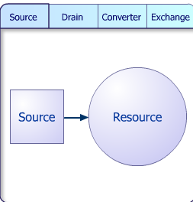
The Resource Conversion Process
Every resource you define may be able to enter the game or leave it; or be exchanged among players, and in many cases, be converted into another kind of resource.
The place or places that a resource comes from are called its source; the places it goes to are its drain. In many games, the game world starts with a limited amount of a resource already in the game and no more comes in, so it has no source. In others, the resource comes in and never goes out, so it has no drain.
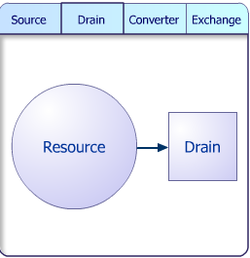
A converter is a process that converts one resource into another, sending one out of the game while the other comes in. An exchange is a process in which resources change hands between players. The resources are neither produced nor consumed but only moved around.
Monopoly is a familiar example of how all this works. The resources in Monopoly are money, properties, houses, hotels, and the “Get Out of Jail Free” card, which is the only card that can be sold. Each player in Monopoly starts off with $1,500. This money is already in the game. The bank is both the source and the drain for money, houses, and hotels. Money comes into the game (through passing GO, getting lucky “Chance” and “Community Chest” cards, or mortgaging property) from the bank. It also goes out of the game (through taxes fines, loans, and interest) back to the bank. For example, the “Luxury Tax” space on the board causes money to drain out of the game back to the bank. Houses and hotels are always bought and sold to the bank alone, and not to other players.
The bank is also the source for properties but it is not a drain. Properties are initially brought into the game from the bank but they do not return there—if a player must turn over money to the bank in payment of a debt, the property is immediately auctioned off to the highest bidder. Properties have no drain in Monopoly.

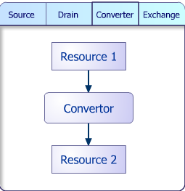
The source of the “Get Out of Jail Free” card is the “Chance” deck, which is also the drain. When the card is used it goes back into the deck.
The primary conversion process in Monopoly is the sale of properties, houses, and hotels from the bank to players. Cash is converted into these items, the item comes in, and the cash goes out. The exchange process is of course, the sale of properties and other items between players—the money and other items stay in the game but they move around. Paying rent is also an exchange in effect, even though the renter doesn't get anything in return.
A much more complicated example of this idea appears in the game The Settlers, a single-player game. The game is almost entirely about manipulating a wide variety of resources—over 20 in all. Wood is one: its source is full-grown trees. The trees can be cut down, cut into logs, and the logs sawn into planks at the saw mill. The planks can then be used for constructing buildings, making tools and weapons, and creating charcoal.
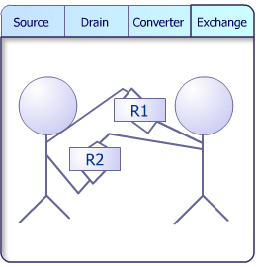
Each of these activities happens through its own conversion process: builders construct buildings, the toolmaker and blacksmith make tools and weapons respectively, and the charcoal burner makes charcoal. In some cases, a conversion process requires more than one resource: the bakery requires flour, water, and either coal or charcoal to make bread. Coal miners require bread to work, so in effect bread is converted into coal. All these conversion processes have a particular rate at which they occur, so a big part of playing The Settlers is getting the timing right so that resources don't build up unnecessarily and workers don't stand idle for lack of them.
The Settlers has very few drains. Even if wood is used to construct a building, half the wood used can be obtained again by demolishing the building. However the people in the game are also a resource and if they are killed, they drain out of the game. For every resource in your game, think about whether it needs a source, a drain, a method of exchange between players, or a conversion process to turn it into another resource. If they do, then think about the production and consumption rates at which they work. These features are the essence of creating an internal economy.

Limited and Unlimited Resources
Notice that in Monopoly, all the resources are limited except for money. There are only so many properties, houses, and hotels to go around. If the bank runs out of them, other players cannot obtain them except by purchase from another player. This creates an incentive to get hold of them quickly. Money, however, is an unlimited resource—the rules state that if the bank runs low, the banker may make new money and add it to the bank. This is an important distinction. If a game's resources are limited and they ever drain faster than they come in, then the game can “run down” for lack of the resource. In The Settlers, water is an unlimited resource; it comes from ponds and the ponds never run low. However, coal, iron, and gold have to be made from their respective ores, which exist only in limited amounts. As a designer this is a key factor in creating an internal economy. Do you want the game to be able to continue indefinitely or do you want it to be able to “run down” as vital resources are permanently consumed?

Completion Conditions and Core Mechanics
Completion conditions or the rules that state how a game is won, lost, or tied are often defined in terms of the core mechanics. They can be characterized in symbolic or mathematical terms or a combination of both known as the hybrid condition. As was mentioned earlier, the victory condition in chess is purely symbolic while the victory condition in Monopoly is purely mathematical.

Let’s look at some of the conditions mentioned last week and assign them to one of these categories:

Completion condition: Get the avatar from one location to another
Symbolic – arriving in one location doesn’t involve numbers

Completion condition: Solve a logical Puzzle
Symbolic – When the state of the puzzle matches a solution state, you have won, otherwise, you have not.

Completion Condition: Do something (like run a race) faster than your opponents
Hybrid – Arriving at a finish line is a symbolic state, but doing it in a lower elapsed time is a mathematical one.

Completion condition: Destroy all enemy forces
Mathematical – You win when the forces drop down to zero

Completion condition: Protect a vulnerable Unit
Symbolic – if the unit is alive at the end of the level (defined by another condition) then you win. If the unit dies, you lose immediately.

Completion Condition: Find a hidden object
Symbolic – when you find an object, you win immediately.

Completion condition: The avatar has used up his health (or lives)
Mathematical – You lose when health drops to zero

Completion condition: The time to accomplish something has run out
Hybrid – accomplishing a task may be mathematical or symbolic one. The timer is mathematical.

Completion condition: All resources or units of some kind (money or troops) have run out.
Mathematical: You lose when any of these items drops to zero.

Completion condition: An opponent achieved something before the player did.
Hybrid: This is simply the inverse of the victory condition for a race. You lose the race when a particular condition (usually symbolic) occurs for an opponent before it does to you.

Completion condition: The avatar is stuck and cannot move.
Symbolic – the ability to move is (usually) not determined by mathematics.

On a final note, test the victory condition in the same way as you have described it to the player.
The game Interstate '76 contained a classic error. The game involved driving around the American Southwest as a sort of automotive vigilante, shooting at bad guys with a variety of weapons. In one level, the player was told that to win he had to find a way out of a walled compound. The designers had built in a hidden ramp, which, when found would enable the player to jump over the wall. They tested for victory in the level by checking if the player had used the ramp. However players soon found another way out: they could drop a land mine near the wall and then run over it at full speed. The mine would blow their car up into the air and out of the compound. But because the software only tested for “using the ramp” rather than “being out of the compound,” it didn't award victory to the player and the level never ended. The player had accomplished what he was told to do but not rewarded for it.
When you build a game, be sure to test the victory condition exactly as you have described it to the player—he might achieve it in some way you didn't expect!

Conclusion
The core mechanics are what make the game tick. They don't control how it looks, but how it feels. If you make a skateboarding game set on Mars, the gravity will be different, affecting the physics of the skateboarder and consequently, the nature of the challenge. The player must learn to interact with the game in an unfamiliar environment—not only visually unfamiliar but physically unfamiliar as well. It is the physical aspects of his experience that are controlled by the core mechanics.
In any game that involves physical, economic, or other mathematical interactions, balancing and tuning the core mechanics is an essential part of game development. For a game to be fun, it must feel right. A game that looks good but has poor mechanics won't be enjoyable to play, so refining those mechanics takes up a great deal of a developers' time. We'll discuss that in the next lecture.

Balancing the Core Mechanics
The core mechanics of a game determine how it works. Once you have them defined, it's time to adjust the core mechanics to make sure that the game works well. It must be fun and fair to play. This adjustment is commonly called balancing the core mechanics.

We balance games for three reasons:
- To make sure that the player or players perceive the game to be fair. If it's a player-versus-machine game, the player must feel a sense of fairness. The challenges should make sure that the player feels that the chances that the machine wins the game are almost the same as those of his winning the game.
- To make sure that the game is not too hard or too easy. If it's a player-versus-machine game, it must offer an enjoyable challenge but the challenges shouldn't be so hard so as to make it impossible to win the game.
- To make sure that the game does end at some point. This will be discussed in more detail in the lecture on “Feedback in games.”

When you're thinking about balance, games may be divided into two categories: those in which one or more players compete together against the machine and those in which two or more players play against each other, either individually or in teams. We'll call the former group "player-versus-machine" (PvM) games, and the latter group "player-versus-player" (PvP) games. The way in which you balance these two types of games is quite different.
Let's now find out how to achieve this balance.

Symmetry
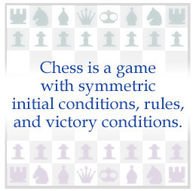
By far the easiest way to balance any game is to make the game symmetric, which means that all the players play by the same rules under the same conditions. Chess and most simple board games are symmetric. In Monopoly too, every player starts at the same location on the board with the same amount of money. These identical conditions are usually sufficient to guarantee that the players feel the game is fair.

In a turn-based game, there is one aspect that cannot be symmetric—someone must go first, unless it is the sort of game in which all players move simultaneously. Going first may or may not make a difference. In a very short game, like Tic-tac-toe, going first is crucial. You cannot win against an intelligent opponent unless you go first. However in Chess the pieces are far enough apart that moving first doesn't present an overwhelming advantage. In addition the rules of the game are such that the player who goes first can only move a pawn or a knight, so the influence of that first move is limited.
You can improve the players' perception of fairness by choosing randomly who gets to go first. In Monopoly, this is governed by a throw of the dice. This way the players feel that although the person who goes first has a minor advantage, each one had an equal chance of going first. Simple player-versus-player games are often symmetric but long and complex games usually are not. Symmetry is an easy way to create balance but it constrains the design of the game to an artificial, often abstract, situation. To create a game with a larger fictional element or richer gameplay, it's often necessary to make it asymmetric.

Asymmetry
In asymmetric games, some aspect of the game is different for each of the players. There are three places where games can be asymmetric:
- The initial conditions. The players might not start with the same number of pieces or resources and they might start at different positions on an asymmetric board. Boards based on the maps of a landscape are almost always asymmetric and some areas may be more valuable than others. The board game Risk is a good example. The map is based on the whole world, and the continent of Australia is particularly valuable because it can only be attacked from one direction. Anyone who starts in Australia is at a decided advantage. In war games based on real wars, the different sides obviously have different positions, numbers of troops, types of equipment, and so on.
- The rules of play (including the core mechanics and internal economy). Remember from the lecture on core mechanics that the rules include the required, permitted, and forbidden actions. These may be asymmetric for different players.
- The victory and loss conditions. In symmetric games, each player tries to achieve the same goal. In asymmetric games, the players may work towards entirely different goals, and whichever side achieves their first, is the winner.
A good example of these principles occurs in Fox and Geese, a board game from medieval times. One player plays the geese and has 18 pieces (there are many variants of the game with different numbers of geese). The other plays the fox and has only one piece. Their initial conditions are clearly very different. The fox may move both towards and away from the geese, and it may jump over a goose (as in checkers) to remove it from the board. The geese, however, can only move towards the fox, never away, and they cannot jump over it—asymmetric rules of play. Finally their victory conditions are different: the geese try to pin the fox into a corner so that it can't move or jump but the fox tries to eat (jump) so many geese that it can no longer be pinned into the corner. As you can see, all three aspects are asymmetric, which is necessary to balance the game. If only the initial conditions were different, the fox would lose every time. An asymmetry in one area has to be balanced by a different asymmetry in another area.
A computerized example of asymmetry appears in the computer war game Starcraft, in which players could choose one of three races of beings to play: Protoss, Humans, and Zerg. In general, Protoss units are very tough but also very expensive while Zerg units are weaker, yet cheaper. i units are somewhere in between the two other races. ii units heal themselves over time; Terran units can be quickly repaired but only by a special repair unit; Protoss units cannot be healed or repaired but they can use rechargeable shields to defend themselves. These differences encourage players to use different strategies but they don't offer a decided advantage to any one race. Players can choose which suits their own playing style best.
In a symmetric game, you know the game is already balanced because the conditions are equal on all sides. Asymmetry is harder to balance because it's difficult to be sure that a certain quality—such as repairable units in Starcraft—is really equivalent to a different quality on the other side, like rechargeable shields. Asymmetry requires much more playtesting in order to make sure that the game is fair. (This is also why there are so many variants of Fox and Geese and so few variants of Chess—everybody can see that chess is fair, but opinions differ about the fairest set of rules in Fox and Geese.)
Asymmetry offers you far more freedom as a designer. Asymmetric games are richer and more engaging than symmetric games and they enable you to simulate real historical situations if you want to.

Balancing Player-vs-Player Games
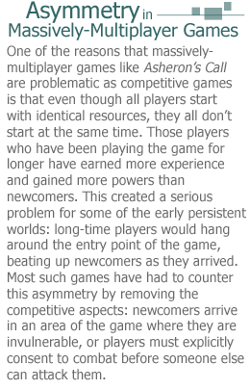
To balance a PvP game, your main concern is the perception of fairness. So long as the players believe that the odds are not stacked against them, they will be happy with the game's balance.
If you're creating a game in a completely new universe, like Starcraft, the best way to balance it is to start with symmetric balance in all three areas: initial conditions, core mechanics, and victory conditions. It's tempting to immediately begin thinking of all the interesting different qualities that you would like to have between your different sides but it's best to get your core mechanics working as a symmetric game first. Define the core mechanics for the game so that they're the same for everybody. Once you are happy with them and the game is playable as a symmetric game, then you can start to make changes. For each asymmetric change that you make for one side, there should be a counterbalancing asymmetric change for the others. It's best to make these adjustments one at a time and playtest each one (even just on paper) before adding another new one.
If you're designing a game in which you have no choice about the differences in the initial conditions (perhaps because they're based on historical fact, as in Axis and Allies, a game based on World War II,) then you'll have to balance those differences with different victory conditions. In a game about a castle siege, for example, the victory condition for the besiegers is to break into the castle and take control of it. The victory condition for the defenders is to hold out for a certain amount of time.
If for some reason you can't get an asymmetric game to balance through its visible features, you can always change the probabilities calculated by the computer. For example, if you're really wedded to a particular asymmetric feature but it simply gives one player too much of an advantage, you can “load the dice” in favor of the other player a bit, so that while one has a visible advantage, the other seems to have better luck. However this is a last-ditch measure and it should be used only when you have no other choice. The effect must be subtle or the players will detect it and feel that something is wrong somewhere.

Balancing Player-vs-Machine Games
Balancing the PvM game is very different from balancing PvP games for a variety of reasons:
- In PvM games, the players are competing against the computer and the nature of the game world is almost always asymmetric, unless the computer is playing the part of a human player in a game like Computer Chess. Most videogames are not as simple as Chess. Instead a player takes part in a long series of challenges of various kinds, as in the Tomb Raider games. The gameplay of PvM games tends to be more about exploration and accumulative achievement rather than simple competition.
- The computer is rarely smart enough to beat a player in a direct competition through artificial intelligence alone. (Again simple games are an exception.) In a complex war game, for example, computers are seldom able to beat players on equal, symmetric terms as they would at Chess. Instead they compensate for the weakness of their intelligence through asymmetric conditions.
- In PvM games, as a designer, you don't actually want the computer to beat the player all the time. In long games like, say Half-Life, players want and legitimately expect to win the game. It should be your design goal to balance the game in such a way that the computer puts up a good fight but eventually loses in the end. Once the player understands how the game works and has acquired the skills necessary to play it well, the player should win. The trick is to challenge him enough that he has to work at it, but not so much that he becomes frustrated with doing the same thing again and again.
Let's take a simple shooter game as an example of how to balance the internal economy of a PvM game. In our game, we have the avatar with one gun and a number of enemies who are functionally identical to the player, scattered around the landscape. There are three types of resources: the enemies themselves, ammunition (stored in clips), and hit points (stored in medical kits). This is all that we need to build a shooter game.
There are also some parameters:
- The maximum amount of ammunition that anyone (player or enemy) can carry at one time
- The maximum amount of hit points that anyone can have when he's fully healthy
- The amount of ammunition consumed by a shot (say one bullet)
- The number of hit points taken away from a character's health every time he's hit by a shot
- The amount of hit points restored when finding a medical kit
- The initial number of enemies in the game

Balancing such a game is quite straightforward. To make the game harder, start with more enemies and scatter less ammunition and fewer medical kits around for the player to use. To make the game easier, put in fewer enemies, make them weaker, and give the player lots of ammunition and medical kits. That's all it takes to balance a shooter in a numerical sense.
There are other, non-mathematical decisions about the core mechanics that you can make as well. Do enemies look for and use clips and medical kits? This makes the game harder. On the other hand, enemies could also be stupid and ignore clips and medical kits and this will make the game easier.
In short, balancing a PvM game isn't about one player versus another but about the player versus the environment he is in. The job of balancing consists of adjusting the resources the player has to use (in this example, health and ammunition) to match the difficulty of the challenges he faces.

Tips for Balancing Games
Here are a few more tricks for balancing games:
- Modulate the tension. There shouldn't be non-stop frenetic action. Build places into your game where the player can take a breather and play at a slower pace for a little while.
- Require the player to explore for information. War games and shooter games use this extensively. The layout of each new level is unknown to the player until he explores it. He is at a significant disadvantage until he explores the complete level at least once.
- After every big battle, give the player a reward. This makes sense both for psychological and balance reasons. The player feels entitled to a reward after a particularly difficult achievement and if he gets one, it is an incentive to keep playing. In addition if his avatar has suffered considerably in the battle, he may need an extra dose of health points, new weapons, etc. in order to go on.
- Don't kill the avatar without warning. The cautious player, moving carefully and being observant should get some indication that he's in a dangerous place. It's not fair to just clobber the avatar without warning. It turns into a trial-and-error puzzle, one of the worst design errors you can make.
- Gradually increase the difficulty from level to level. This not only gives the player an ever-increasing sense of achievement but it also balances the game against his growing skill as he plays it.
As you go into designing and balancing your core mechanics remember the following:
- Be thorough in the initial design. Balance it as best you can in theory to reduce the amount of tuning you have to do in practice.
- Don't expect that you can get it perfect in theory and never have to tune it at all. No matter how hard we try, videogames are too complex to be built on theory alone. Even if the math all looks alright, there's no substitute for testing the game in running software.
One of the articles in your assigned reading looks at feedback—an important element in controlling the balance of a game as it is played.

Balancing Games with Positive Feedback
By Ernest Adams
Gamasutra
January 4, 2002
URL: http://www.gamasutra.com/20020104/adams_01.htm
Most of the time The Designer's Notebook is full of opinionated jottings about creativity, storytelling, or the social effects of interactive entertainment - in other words, blue sky. Every now and then, though, I feel compelled to write something abstruse and technical about game design, something that's more of a how-to than a why-to or a why-not-to. This is one of those times. This month I'm going to talk about the effect that positive feedback has on game balance.
What Is Positive Feedback?
When we speak of feedback in everyday life, we're usually referring to that horrible shriek that happens whenever the microphone in a public-address system gets too close to the speakers. The mic picks up whatever's coming out of the speakers and tries to amplify it again. More generally, feedback occurs whenever the output of any system is "fed back" into it as some kind of an input. What happens with the microphone and the amplifier is an example of positive feedback - a situation that tends to amplify the output of the system.
Positive feedback plays an important role in game design, although you don't hear many designers talking about it. It can gravely harm a game if improperly implemented, but it also has significant benefits. It's an element of game design that every designer needs to understand and learn to use.
Before I go into how it works, though, let's look for a minute at the way games are won and lost. When you happen across two friends playing a game, what's the first thing you say? "Who's winning?" of course. That's not always an easy question to answer. Some games have a metric that determines who's ahead at any given time; others don't. In ping-pong, for example, it's obvious: whoever has the most points is winning. In chess, it's less clear because the victory condition - checkmating the king - is not defined in terms of accumulating points. You can very generally say that whoever has taken the most pieces is winning, but it's perfectly possible to win at chess with fewer pieces than your opponent has.
In game design, positive feedback can be defined as occurring whenever one useful achievement makes subsequent achievements easier. In other words, whenever someone gains something in a game, it gets easier to make further gains. If the role of positive feedback in a game is too great, then whoever first obtains the slightest lead in the game is guaranteed to win, because they just keep getting farther and farther ahead. This makes it sound as if positive feedback is always undesirable, but it isn't; it's just a question of employing it properly.
Positive feedback appears mostly in games in which the victory condition is defined in numeric terms, and throughout the game you're working to achieve that victory condition by accumulating something. In Monopoly, for example, it's money. Obtaining money in Monopoly allows you to buy and improve properties, which makes it possible to obtain more money. Positive feedback can also appear in games in which a numeric advantage of some kind helps to achieve a non-numeric victory condition. Although the victory condition in chess is non-numeric, it does generally help to have more pieces than your opponent.
Balance Graphs
So what are some of the effects of positive feedback on games? I think it will help to look at something I'm calling a balance graph, although there's probably a different name for it in formal game theory. I've included several of them below. A balance graph plots the progress of a zero-sum two-player game. Time is represented on the horizontal axis. The vertical axis indicates who's ahead by some numeric metric, usually the difference in points scored by the two players. If player A is ahead, the number is above zero; if player B is ahead, it's below zero. At the left edge of the graph, the beginning of the game, the players are even at zero. Dotted lines at the top and the bottom of the graph indicate the victory condition for either player A or B.
My first balance graph represents a simple sprint foot race in which player A is a faster runner than player B. A immediately goes ahead and remains ahead for the duration of the race. Straightforward races have no positive feedback. Gaining the lead does not make it easier to retain or increase the lead. (In fact, there's psychological evidence to suggest that the opposite is true: runners try harder if there's someone slightly ahead of them. When Roger Bannister was training to break the four-minute mile, he ran with pacesetters who ran in front of him. This phenomenon has also been observed in racehorses and sled dogs. However, it isn't part of the rules of the game, which is what we're concerned with here.)
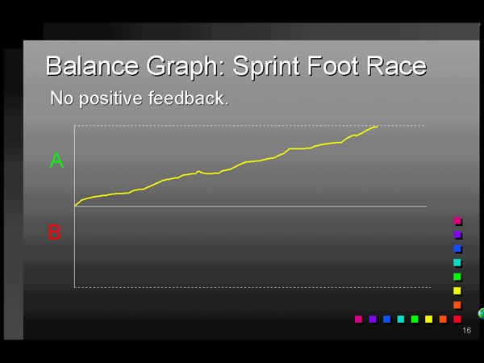
Figure 1

The next graph is an example of an unbalanced, i.e. unfair, game - whether or not it includes positive feedback. Assuming that A and B are of equal skill and there is no element of chance involved, something about the rules is giving A an advantage, such that she takes the lead and maintains it throughout a very short game.
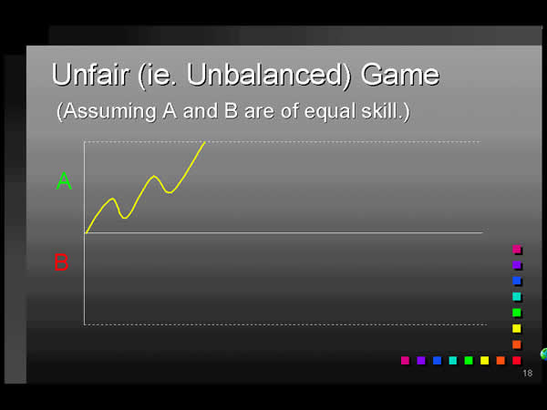
Figure 2
In Figure 3 we have a stalemate, a game that goes on forever with neither player able to assume a commanding lead. This is a game that's too balanced: neither player is able to achieve victory. The children's card game War is a good example of this kind of game: it's all luck, no skill, and no positive feedback, so it can go on for hours. This illustrates why positive feedback is a useful thing: it helps to prevent stalemates. Once a player assumes enough of a lead, the advantage that positive feedback confers guarantees that he will win.
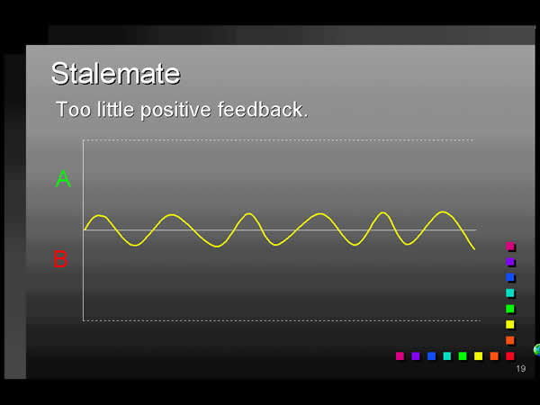
Figure 3
Figure 4 illustrates a game that's balanced, but positive feedback sets in too soon, producing a fair but very short game. B gains a slight advantage, then A retakes a slight lead, then B again, then A takes a longer lead and promptly wins the game.
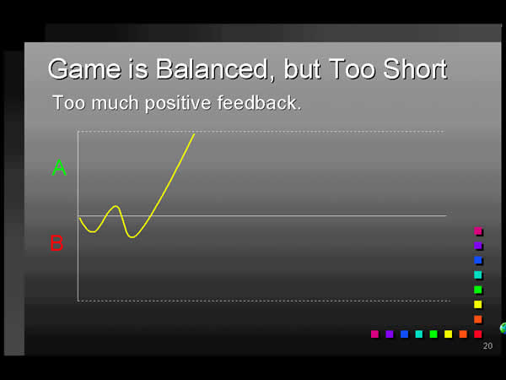
Figure 4
The ideal game, in my opinion, starts off even and balanced, but slowly becomes unbalanced over time until one player inevitably wins - preferably the better player! Figure 5 shows one example, although in this case player B struggles on valiantly for quite a while.
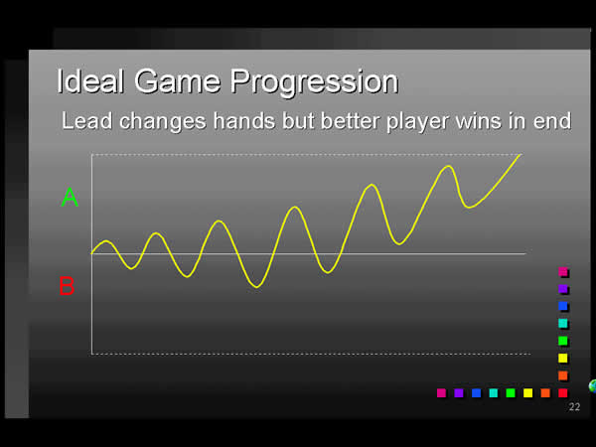
Figure 5
Once a player's lead becomes commanding, the game shouldn't take too long to finish. This is one of the (very few) problems with Monopoly. From the time that it becomes clear that one player must win until he has actually bankrupted all the other players is usually half an hour or more. The other players just have to sit and wait through their slow slide into oblivion.
Positive Feedback in Games
So let's look at some examples of games with and without positive feedback. As I mentioned before, races and most other athletic competitions don't have positive feedback - at least, not designed into the rules. Scoring points in basketball doesn't make it any easier to score further points. Nor do most card games: cribbage or rummy, for example. On the other hand, war games definitely do have positive feedback, especially if the victory condition is simply to wipe out all the other player's units. Destroying an enemy unit confers an advantage to the player who does it. The unit no longer there to fight back, so it's easier to destroy the next unit, and so on.
Another genre of computer game that has positive feedback is single-player role-playing games. You start off with poor weapons; you kill some monsters; you get some treasure, and you use it to buy better weapons. The better weapons enable you to kill more monsters, you get more treasure, you buy still better weapons, and so on.
Positive feedback needn't have a direct influence on the path to victory; it can appear in other areas of a game as well. While I was at Bullfrog Productions, I was lead designer on a new game (never published, alas) called Genesis: The Hand of God. Genesis was a god game in the spirit of Bullfrog's original Populous, in which you could affect the weather of a landscape with divine power, drawing on mana generated by your simulated worshippers to do so. One of our innovations was that there were several different types of mana, depending on the nature of the landscape in which your worshippers lived. For example, if they lived in a wet area, you got a lot of water mana, which you could use to make rain. Of course we realized immediately that this was a positive feedback loop: the more water you had, the more water you could get. On the other hand if your people lived in a desert, it was very difficult to make rain because they were producing very little water mana.
In the end we concluded that this wasn't a problem for the game. Making rain in a wet area made it wetter, but so what? If you made it rain all the time you would drown your own people, and there was no benefit in that. We also thought that making the desert bloom shouldn't be too easy at first, but once you got it started, it should get easier. Although it was positive feedback, it didn't endanger the balance of the game because it didn't confer a direct advantage over your opponents.
Controlling Positive Feedback
So far I've looked at both the benefits and the dangers of positive feedback. The benefit of it is that it prevents stalemates, helping games to come to an end. The danger is that it will unbalance a game too quickly and bring it to an end too soon. So how can we limit positive feedback? There are several ways.

Use Negative Feedback
Negative feedback is the opposite of positive feedback; it's an effect that tends to diminish, rather than amplify, the output of a system. A good example of using negative feedback to control positive feedback is the way that the player draft works in American professional football. In general, a team that wins a lot is going to have more money than a team that loses a lot. A winning team could use that money to outbid other teams to hire the best new players graduating from college. The best teams get more money, which enables them to hire the best players, and so they continue to win. Poor teams can only afford poor players, so they continue to lose - a clear case of positive feedback.
In order to prevent this, and try to balance the strength of all the teams, the National Football League introduced a drafting system. New players can't simply auction themselves to the highest bidder; rather, the teams take turns to choose players from those available, and most importantly, the worst teams choose first. This means that the worst teams get first choice of the best players, and the quality of the teams is evened out somewhat. Of course, it's not that simple in practice; teams are allowed to trade their positions in the selection order, and the quality of their play depends a lot on the quality of the coaching, not to mention the other players already on the team. But the principle is sound. The draft system helps to prevent one team from establishing an unassailable position through positive feedback.
Be careful about negative feedback, however - if it's too strong, it can produce stalemates or even wild swings in the lead, as Figure 6 illustrates. In this example, being in the lead confers some kind of strong disadvantage that causes the lead to flip to the other side and back again.
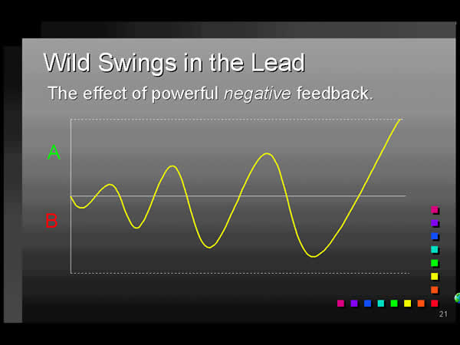
Figure 6
You often see this in turn-based multi-player party games for adults, in which the object isn't really to reward skill, but to have a good time without worrying too much about who's winning. Everybody gets to be in the lead at some point, and the winner is mostly a matter of chance.
Limit the Benefits that Positive Feedback Provides
In chess, it's obviously helpful to remove your opponent's piece from the board. But imagine what chess would be like if you could not merely remove the piece, but turn it into one of your own. This would confer a much greater benefit to taking an opposing piece, in other words, stronger positive feedback. Chess games would be shorter. This actually happens in Japanese chess, which is called shogi. A player who has removed an opposing piece from the board may reintroduce it at a later point as one of his own (with certain restrictions).
This is why most real-time strategy games don't allow you to seize enemy units and use them yourself, nor do they allow you to take over enemy production facilities. If you could grab your opponent's factories and start turning out units for your side, the game wouldn't last very long. They are limiting the benefits that positive feedback provides.
In addition to the drafting process, pro football has other rules that help to prevent the wealthiest teams from dominating all the others year after year. One rule is the salary cap, which limits the total amount that each team may pay all its players. No matter how much money a team has, it can't spend more on salaries than the salary cap dictates. Another is a fixed team size. No team can have more than 53 players during the regular playing season, even if it can afford to. These artificial restrictions serve to constrain the effects of positive feedback. In effect, they're making sure that "money isn't everything."
Define Victory In Other Terms
As I mentioned earlier, the victory condition doesn't have to be defined in terms directly influenced by positive feedback. In chess, victory is defined in strategic rather than numeric terms. In real-time strategy games, you can create missions in which victory must be achieved by stealth, or by detecting a weakness in the enemy defenses, or by surviving for a certain amount of time, or any number of other scenarios. One of the weaknesses of RTS's at the moment is that too many of them depend on overwhelming the enemy with sheer numbers - in effect, production efficiency - rather than rewarding strategic skill. This leads to a "cannon-fodder" mentality among players that is uncomfortably reminiscent of Field Marshal Haig at the Somme. Let's hope they don't practice using those kinds of games at West Point.
Ratchet Up the Difficulty Level to Compensate
This is exactly what role-playing games do. As I described above, there's clear positive feedback in the character growth: winning battles enables you to buy better weapons which enables you to win still more battles. If you always faced the same kinds of opponents, you would quickly become invincible, and the game wouldn't be much of a challenge. Therefore, as your character's strength and ability grows, the game increases the toughness of your enemies as well. The difficulty of winning each battle remains fairly constant (with local variations) throughout the game.
Increase the Influence of Chance
This isn't the best way to reduce the effect of positive feedback, but it does work. Monopoly does this to some extent. One bad roll of the dice can set the leading player back significantly. Of course, it can hurt just as much as it can help, unless you load the dice against the leading player - and if you do that you'd better not tell them about it! Children's games tend to rely on chance more than games for adults do. It helps to balance out disparities in skill and allows the loser to blame bad luck rather than himself (I don't necessarily endorse this, I merely note it).

Conclusion
Balancing a single-player computer game is a bit different from balancing a multiplayer one. In a single-player game it isn't necessary to be "fair" in quite the same way as it is in a multi-player game. The challenge in single-player real-time strategy and role-playing games usually depends more on the player's ignorance of what he's up against than the computer's strategic or managerial skill - often because the computer doesn't have much. But most RTS's are designed with multiplayer modes these days, and in those cases it is necessary to balance them properly and make sure you're being fair to each player, especially if they have asymmetric forces. In multiplayer mode, positive feedback has an important role to play. Use it wisely!
Copyright © 2003 CMP Media Inc. All rights reserved.

Statistically Speaking, It's Probably a Good Game, Part 1: Probability for Game Designers

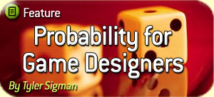
Quiz Time — Whoopee!
Q1) You are designing a new MMORPG, and you set a particular item — Orc Nostril Hair - to drop 10% of the time when a certain species of monster is killed. One of your testers reports back that he killed 20 of the monsters, and found the Orc Nostril Hair 4 times. Another tester killed 20 of the monsters and never found a single Orc Nostril Hair. Is there a programming bug?

Orc Nostril Hair Follicle
Image of Similar Hair Courtesy Wikipedia
Q2) You are designing a combat system for a game and have decided to include a critical hit mechanic. If the character lands a successful hit (say 75% base chance to hit), then you roll another hit check. If the second hit check is successful, the player will do double damage (2x). However, if this happens, you roll another hit check, and if that’s successful, then the damage is upgraded to triple damage (3x). As long as each hit check is successful, you keep making new checks, and the damage multiplier keeps increasing until a hit check is missed. What percentage of the time will the player get at least double damage (2x)? What percentage of the time will the player get quadruple damage (4x) or better?
Q3) You have decided to include a gambling mini-game in your latest magnum opus RTS-FPS-tamagotchi-sports hybrid game. The gambling mini-game will be very simple: the player can wager rubies on whether a coin flip will come up heads or tails. The player always receives even money on his winning bets. You will make the coin flip as fairly programmed as possible (50%/50%), but you will include an extra feature for the player: a list of the last 20 coin flip results will be shown on the right side of the screen. Should you beg the programmers to include any extra logic to prevent the player from taking advantage of this 20-flip history and using it to bankrupt your entire in-game economy?
We’ll attack the answers to these captivating questions at the end of this piece (if you’re still awake).

Game Designers - Renaissance People and Anti-Experts

Designerus Gamus
Being a designer in this day and age requires a pretty wide variety of skills. Designers are the generalists of the development team, needing to bridge the gap between Art and Engineering, competently communicating with each — or at least competently faking it. A good designer requires a basic understanding of a lot of different things, because game design is a haphazard amalgamation of subjects.
It’s pretty common to hear designers debating or waxing poetic on the finer points of linear or non-linear storytelling, human psychology, control ergonomics, or the integration of non-interactive sequences; less often do you catch them mulling over the bare bones details of the hard sciences like calculus, physics, or statistics. Sure, there are the Will Wrights, determined to find fun in celestial goo and the dynamics of city traffic planning. Most, though, wince when equations start breathing down their necks.
Probability + Statistics = Cool
Probability (P) and Statistics (S) are two hard sciences that are hugely important to game designers—or at least should be! They go together like peas and carrots, but like those yummy veggies, they aren’t the same thing. Coarsely put:
Probability: predicts the chance that an event will happen
Statistics: draws conclusions based upon events that have already happened
Taken together, P and S allow you to perform amazing parlor tricks: you can both predict the future and analyze the past! What power! Remember, though: “With great power comes great responsibility.”
P and S are simply tools in your Designer’s Toolbox (you know—the one under your desk). You can and should use them to your advantage to design games that are better balanced and ultimately more fun!
Good and Bad Things Come in Threes
There are lots of scary, thick textbooks out there about P and S, and this discussion isn’t meant to be a substitute for you going out, doing your due diligence and reading them. (Note: falling asleep with them on your chest *does not* count as learning.)

What this series of 3 articles *will* do is give you a basic understanding of some key topics from both P and S. Specifically, we’ll focus on things that designers should give a rat’s behind about.
- Part 1 (You’re reading it, buster): Probability for Game Designers
- Part 2: Statistics for Game Designers
- Part 3: Shaping Game Mechanics with Probability and Statistics
Remember, being a well-rounded designer doesn’t mean you have to be an expert in these things; you just have to be able to fool anyone else who isn’t!
TIP: Increasing your usage of “theoretically”, “codify”, and “taxonomy” will most certainly impress your coworkers towards these ends. Other disciplines love it when designers use big words! You can thank me for this wisdom later.

The Ivory Tower in Which Designers Live
Ok, enough beating around the bush — on to the good stuff!

P R O B A B I L I T Y
Most games have one or more elements of probability incorporated into their base mechanics. Even chess requires the flipping of a coin to determine who takes white. Usually, we call probabilistic mechanics “random events”. Of course, the term random really might mean “completely random” or “sculpted random.” Regardless, whether you’re talking Texas Hold’em, World of WarcraftTM, or BombermanTM, random events are integrated into key game mechanics.

Probability: It’s not Just a Good Idea...It’s the Law!
You’ve probably heard the term “according to the laws of probability.” The key word in the phrase is “laws.” Probability is all about indisputable facts, not guesses. Ok, technically it’s all Probability Theory, but for the purposes of game design you can compute probabilities absolutely. When you roll a six-sided die, the chance of rolling a “6” is 1/6 = 16.7%—assuming a fair ‘throw’ and a perfectly manufactured die, of course. This 16.7% is not a guess, nor anything of the like. It is as good as fact*. Many of the most common thought errors that people make concerning probability have to do with the belief that probability is not based on laws, but rather on approximations or guidelines. Don’t fall into the traps! I’ll mention a few of the most common ones below, and try to draw some big DANGER! signs around them.
*I guess there might be quantum mechanical concerns that make the 16.7% not exactly fact. I mean, the die could suddenly warp out of existence or maybe your act of looking at it unfairly forces it to collapse its wave function (a severe inconvenience, to be sure).

Independent and Related Events
Let’s start our whirlwind tour of Probability’s Greatest Hits with a key distinction: whether events are independent or related. It’s vital to know before you can start calculating probabilities.
Independent Events: The chance of each event occurring does not depend in any way on what happened in the other event. For example, rolling a six-sided die (event #1) and then rolling it again (event #2) are independent events. The first and second rolls are not related in any way. The number you rolled in event #1 has absolutely zero influence on event #2 (see the “Fallacy of Equipartition”, later). Another example of independent events is drawing a card from a poker deck and then drawing a card from a second, totally different deck.
Related Events: the chance of each event happening is related in some way to the other event. For example, drawing a card from a poker deck (event #1) and then drawing a second card from the same deck (event #2). The chance of drawing a Jack on event #2 is affected by event #1—if you drew a Jack on event #1, then there’s a smaller chance of getting one in event #2 because there are less Jacks remaining in the deck.
Conditional Probability
One of the most useful bits of probability to know is how to calculate the chances of conditional events—that is, events that rely on other events occurring. For example, I used to play lots of old WarhammerTM tabletop games which are d6 based. According to the “to Hit” charts, if you had a somewhat unskilled warrior (with a low Weapon Skill) matched up with a superior enemy, you might have to roll a “6” followed by a “6” in order to hit. Just what is the chance of rolling a “6” followed by another “6”?
Well, first things first, you have to get the first “6” out of the way (a 1/6 chance). Then, you need to roll another “6” (a 1/6 chance again). Whenever one event depends on another’s success, you multiply the chances to get the cumulative chance of both occurring. In this case, it’s a 1/6 x 1/6 = 1/36 chance to roll a “6” followed by a “6”. (Note: If you have an irrational fear of rational numbers—har har—then you can always convert the fractions to decimals by using your calculator. In this case, 1/36 = .028 = 2.8%)
Armed with this newfound power of Conditional Probability, it’s very easy to calculate the chances of crazy dice throws. What are the chances that you can roll four “6”s in a row? The answer is 1/6 x 1/6 x 1/6 x 1/6. Or more simply, (1/6)4 = .0008 = .08%. How about ten “2”s in a row? (1/6)10 = AnIncrediblySmall%.

Incontrovertible Visual Proof that Four “6”s is Possible
Ratcheting up the difficulty, how about the chances of rolling a “3” or above followed by a “5” or above? It’s just 4/6 x 2/6 = 8/36 = 2/9 = 22.2%. Now we’re rockin’ the free world!

Superstition and the Fallacy of Equipartition — aka “The Gambler’s Fallacy”
One of the most common and widespread thought errors that people make concerning probability is blurring the line between independent and related events. This typically takes one of the following forms:
BAD THINKING AHEAD!
Mistake 1: Believing that a “5” is less likely than normal to appear again because the last dice roll was a “5”.
Mistake 2: Believing that a “6” has a very high chance of being thrown because 10 rolls have gone by without a “6” being thrown. Dressed in another outfit, this is believing that “red” is due on a roulette wheel because it has been several spins since the last “red” hit.
Mistake 3: After flipping a coin 10 times and getting 8 heads and 2 tails, believing that the next 10 flips will have more tails then heads in order to “even out.”
These all loosely fall under the appropriately well-named “Gambler’s Fallacy.” Basically, this is just the name for confusing independent and related events. Another name for this fallacy is “I just lost all my money at roulette because the Laws of Probability defied me Fallacy.” It is closely related to the lesser-known “Why do casinos allow me to keep a written log of the recent roulette spins — surely they know that I’ll be able to figure out the pattern and beat the wheel Fallacy?” (Note: that last fallacy typically is followed quickly by the previous one.)
Don’t fall into these traps! Rolling a die multiple times or spinning a roulette wheel are independent events, pure and simple. Let’s examine each of the above mistakes more closely:
Mistake 1: The chance of rolling a “5” on a d6 is 1/6 = 16.7% This never changes. It doesn’t matter if you’ve thrown eight “5”s in a row or haven’t seen a “5” since Gilligan’s Island premiered. 16.7% is still the magic number. “Dice don’t have memory” is a common phrase overheard...and it’s correct!
Mistake 2: Same as above. The chance of rolling a “6” or hitting “red” has absolutely nothing to do with the rolls or spins that came before. Roulette wheels don’t have memories either (unless they are actually magnetized and “Vinnie the Spinnie” is making sure that your number never comes up).

The most common argument that people make for mistakes 1 and 2 goes something along these lines:

GAMBLER’S FALLACY, scene 24b:

INT. HALLWAY — NIGHT
The moon shines in, bathing the office in silvery luminescence.
Game developers roam the halls like zombies, crunching for a
milestone. Or crunching human bones...

Mr. Faulty bumps into Probability Stuffshirt; both jolt out of
their zombie-like zombified zombie trances.

MR. FAULTY
(wryly)
Surely you agree that rolling
three “5”s in a row is unlikely.

PROBABILITY STUFFSHIRT
Yes. The chances are 1/6 x 1/6 x
1/6 = 1/216 = less than 0.5%, to
be exact.

MR. FAULTY
Well I’ve just rolled two “5”s in
a row, so my chance of rolling
another “5” right now is surely
very, very small! Less than
normal!

PROBABILITY STUFFSHIRT
Actually, your chances of rolling
another “5” right now are 1 in 6 =
16.7%.

MR. FAULTY
How can I have a 16.7% chance if
there is only a 0.5% chance of
rolling three 5’s in a row? I’ve
got you!

A well-dressed, distinguished looking NARRATOR emerges from a
small space behind the water cooler. He addresses the camera
directly.

NARRATOR
Mr. Faulty is making a patently
bad but sadly common argument.
Let’s hear why...

PROBABILITY STUFFSHIRT
Not so fast. You have already
rolled two “5”s in a row. The
chances of that were a mere 1/6 x
1/6 = 1/36 = less than 3%. You’ve
already done the hard part. Now
all you have to do is roll another
“5”, and you have a 1/6 chance to
do it. If you succeed, then that
completes the 1/6 x 1/6 x 1/6 =
1/216 = 0.5% Take that!

MR. FAULTY
(pointing wryly)
What could that be over there!
(escapes to cubicle)

The Law of Averages Got Vetoed
Mistake #3 (from back before Scene 24b) is a similar, but extended error: believing that over the long run, everything will “even out” — the Law of Averages. It’s true that, out of 1000 flips of a coin, you’d expect to see roughly 50% heads and 50% tails. But there is no such thing as a “correction.” If you flip a coin ten times and get 8 heads against 2 tails, there is no global essence or power that is going to squeeze a few more tails into the next 10 flips. You would be making a grave philosophical error to assume that “tails are due”, and an even graver error to put big money on it. Peter Webb has an excellent short discussion on this subject at his website (see recommended reading at the end of this article).
The gist is, if you flip a coin 1 million times, you’ll expect the heads and tails split to be close to 50%. But don’t expect the NUMBER of heads flips to equal the NUMBER of tails flips — in fact, it’s very likely that they will be off by hundreds or even thousands. Remember, you could have 10,000 less heads than tails and the division would still be very close to 50%/50% (49%/51%, to be exact). So don’t put money on assuming that an 8-to-2 heads lead (+6 heads) will be corrected as you flip more coins! It’s very likely that even if the heads/tails split will be close to 50%/50% in the long run, the actual difference between number of heads and number of tails will probably grow as the total number of flipped coins grows.

Converse Probability
It’s easy to find formulas that will help you calculate the chances of independent or related events. Sometimes, though, it can be very, very difficult to calculate more involved probabilities. One trick that you can pull out of your hat to save the day is the concept of “converse probability.” To calculate converse probability, instead of trying to determine the chances that something will happen, you instead calculate the chances that something won’t. Then, you subtract this number from 1.0 (100%) to get the probability that you are looking for.

Converse Prob 101: Easy Example
You are about to roll a six-sided die. What are the chances that you’ll roll a “6”? Although we already know the answer, we’ll use converse probability to verify it. The chances you won’t roll a “6” are 5/6 (5 out of 6 of the die sides are not a 6). Therefore, the chance of rolling a “6” is 1 – 5/6 = 1/6, or the familiar 16.7%. In other words, if you won’t roll a “6” 5 out of 6 times, then you will roll a “6” 1 out of 6 times. That almost makes sense!

Converse Prob 201: Flush with Excitement
Here’s a situation where converse probability really is a money saver. It’s Texas Hold’em, and you are four cards to a heart flush with two cards to come. In other words, if a heart comes on the Turn or the River, you’ll complete your flush**. What are the chances this will happen?
**Given the choice between the two, I recommend completing your flushes on the River — this has the greatest chance of psychologically destroying your opponents and sending them into apoplectic fits. Nobody likes getting Rivered.

It’s very easy to calculate the chances of a heart coming on the next card. There are 9 hearts remaining “in the deck” that have not been flipped up yet (13 to begin with minus the 4 already showing between the flop and your hand). There are 47 cards total in the deck (52 minus the two in your hand and the three flopped on the board). Therefore, the chances of flipping a heart on the next card are 9 out of 47, or 9/47. If that card isn’t a heart, then the chance of flipping a heart on the following card is 9/46 (there are still 9 hearts remaining, but one less card total in the deck).
Great, we’re off to the races! Only problem is, how can we easily calculate the total chance of flipping a heart, accounting for both cards? It would be easy to make the mistake of assuming that it would be 9/47 + 9/46. Not true, however. This is the same mistake that can lead you down the dark path of believing that the chance of rolling a “6” on a six throws of the dice is 1/6 + 1/6 + 1/6 + 1/6 + 1/6 + 1/6 = 1.0 = 100% = SureThingTM. Unfortunately, there is not a 100% chance of rolling a “6” on six throws of a die***.
Turns out that the solutions to both of these problems are made easier by using converse probability. We must ask “what are the chances we won’t draw a heart?” For the first card (the turn), the answer is (47 - 9)/47 = 38/47. For the second card (the river), the answer is (46 – 9)/46 = 37/46. From a study of conditional events (see earlier in this article), it’s easy to calculate the chances of BOTH of these events happening. In other words, we must calculate the chance that no hearts are drawn on either card. This is just the product of 38/47 x 37/46 = 65.0%. Since we are actually interested in the chances of making the flush, we just subtract this result from 1.0 to get it. 1.0 – .65 = .35 = 35% So there is a 35% chance of drawing the flush. Now do you go all-in?
***Note: the answer to the little dice problem is figured out the same way. The chance of rolling at least one “6” in six throws is found by looking at the chance of rolling no “6”s. On each throw, the chance of no “6”s is 5/6. Cumulatively, in order for no “6”s to come up in six throws, the chance is just the product of all six throws: 5/6 x 5/6 x 5/6 x 5/6 x 5/6 x 5/6 = .33 = 33%. So, the chance of at least one “6” coming up is 1.0 – .33 = .67 = 67%. Thus, you should see at least one “6” on six throws about 2/3 of the time. Now go use this to make money off somebody.
I didn’t mean to get all “mathy” above, and I was a little sneaky with my blitzkrieg treatment of Hold’em odds. The important thing to remember about converse probability is that sometimes it’s much easier to figure out the chance of something NOT happening than it is to figure out whether it WILL.

An Aside on Random Number Generators
Another thing all digital game designers should know about probability: random number generators are not random! Random number algorithms require a “seed number,” which is a base from which the algorithm can get all medieval on itself and do gyrations that ultimately result in a seemingly-random number. Most of the time, programs sample the CPU clock time or something similar to use as the seed number — this helps the algorithm be pretty darn random. But for high-intensity games with tons and tons of random number generations, sometimes that’s not random enough. Take for example online poker providers. Players (who often gamble for real money) need to know unconditionally that there are no underlying patterns to the random numbers that control card shuffling. In extreme cases like this where money is riding on the outcome, programmers must get super-fancy and start doing things like using CPU heat and entropy as seed numbers instead of clock times.
The take-home here is just that digital games don’t have truly random numbers. Most of the time, that’s fine, but if your game crunches insane amounts of numbers, then beware of patterns.

Quiz Show Redux
If you’ve read this far, then we’re both exhausted. Hopefully, though, we have also developed a nice golden-brown brain tan. So let’s revisit the questions from the beginning of this article.

Q1) Orc Nostril Hair Drop Rates
It’s too early to panic. Never panic unless you are sure you should panic. If you are sure you should panic, then panic, and panic well.
In this case, both testers’ results are certainly within the realm of probability. If there is a base 10% chance of finding the Orc Nostril Hair (ONH) on each monster-slaying, then the chances of finding at least 4 ONH in 20 tries is 13.3% Where did I get that number, you might ask? Well, I cheated and used an advanced concept called Binomial Distribution, but sadly (or happily?) it is beyond the scope of this article.
The chance of finding zero ONH at all through 20 tries is determined through converse probability:
10% chance of finding item on each kill means 90% chance of not finding it (0.90).
Chance of not finding it through 20 kills = (.90)^20 = 12.2%
So there is about the same chance of finding 4 ONH in 20 tries (13.3%) as there is finding zero ONH in 20 tries (12.2%). Not yet cause for justified panic.
To really determine if you should panic, you need more info. You need lots of data points from your testers in order to draw an informed, statistically-based conclusion (OK, I’m jumping ahead to part 2. Indulge me.)
Let’s say you collect info on 100 play sessions, each of which involve 100 kills. That’s a respectable amount of data. If out of those sessions, players are finding ONH a lot less or a lot more than 10% of the time, then you probably have a bug that is affecting your reward rates. In that case, panic with all haste! Tip: Sprinting around the office screaming “No!” generally gets quick results.

Q2) 2x-3x-4x+ Critical Hits
The chances of doing at least 2x damage are found by the conditional probability of hitting twice in a row:
Chance of 2x or better = 0.75 x 0.75 = 56.3%
Chance of 4x or better = (0.75)^4 = 31.6%
Wow. Players will do 4x or better damage almost 1/3 of the time. Fix your system, dude/dudette! Either drop the base hit percentage or make the successive critical levels harder to achieve.


Q3) Will Flip Coins for Money
This question is a silly trap, not-so-elaborately laid. First you give the player help by showing them the last 20 flips, then you need to shore-up your system to present exploits. Sheesh!
The answer, of course, is that providing the player with this 20-flip history changes nothing about the fact that each coin flip is a 50/50 proposition****. Let the player wreck himself with the Gambler’s Fallacy.
Heck, I even recommend paying out less than even money every time a player bets “heads” after 2 successive “tails” results. Just tell ‘em you are adjusting to their unfair advantage of knowing “heads” is due. They’ll believe you, they will...
****Natch, discounting any flaws in your random number generator that simulates the coin flip.

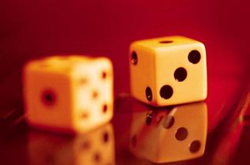
What are the Chances that this Article was Interesting?
I may be a gambling man, but I won’t dare to give odds on that.
If you survived the last few thousand words or even enjoyed them, stay tuned. In Part 2, we’ll explore the “Two-Drink Minimum” science of Statistics. And finally, in Part 3 (the riveting conclusion), we’ll look at the anatomy of a number system and explore how your choices as a game designer can sculpt a game’s mechanics into a true work of art. No, really!

Recommended Reading:
Peter Webb’s “Layman’s Guide to Probability”:
http://www.peterwebb.co.uk/probability.htm
The Wizard of Odds (lots of great gambling prob calcs):
http://www.wizardofodds.com
Brian Alspach’s Poker Computations:
http://www.math.sfu.ca/~alspach/computations.html

Statistically Speaking, It's Probably a Good Game, Part 2: Statistics for Game Designers
By Tyler Sigman
Gamasutra
January 24, 2007
URL:http://www.gamasutra.com/features/20070124/sigman_01.shtml
Welcome Back. I’ve Been Waiting…
If you’re reading this, then chances are you also read Part 1, “Probability for Game Designers.”
If you haven’t read it, you really should, and that’s not to say it is full of good stuff (the article is tripe, actually). I just recommend reading it because if you don’t, you might be unprepared for the silliness that may ensue during this serious *ahem* and erudite *cough* discussion of statistics.
This article focuses on a few select statistical topics that I believe should be understood by game designers. In particular, statistics really is useful and important for system designers, mechanicians, balancers, and other subclasses of designer that are usually relegated to steerage.
Disclaimer taken care of, let’s move on to the fizzy stuff!
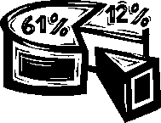
Statistics: A Two-Drink Minimum Science
Although heavily grounded in mathematics, statistics is...well...weird! Seriously - if you ever have to start dealing heavily in two-sided confidence intervals and Student’s T-tests and chi-squared tests (or anything else squared, for that matter), it can get a little hard to digest at times.

The Secret Badge of Statisticians Everywhere
You see, people like me really prefer physical metaphors. I’ve always liked physics and mechanics, because a lot of the time you can give yourself a reality check simply by analyzing reality. When you’re calculating the rate and direction at which an apple falls from a tree, you can reality check it in your head if your result says the apple should shoot off straight upward at 1,224 MPH.
At its best, statistics is understandable and rational; at its worst, it’s a little strange. Hence, I recommend libations and togas for any involved statistics discussion. I have asked the fine editors at Gamasutra to provide such togas and an open digital bar. What, didn’t you get your passcode? Hmmm, weird.
In any case, the topics in this article aren’t weird at all. For the most part, they are tangible, crunchy bits of statistics that you can develop gut feels for.

Statistics: The Dark Science

A Statistician Hard at Work
Statistics is, of all the sciences, the one that is very prone to misuse by the Forces of Evil. That is, if you had to attribute one science to the villain you are creating for your new book (you are writing a book, aren’t you?), you could do much worse than pick statistics. You could also give him a cape, dress him in black, and refer to him as “The Spider” or “Mr. Jones”, but I digress.
The reason that statistics can be loosely compared to villainy is that, used improperly, this branch of science can be called upon to infer all sorts of relationships that aren’t actually meaningful or even true (see the end of this article for an example of what I mean). When in the hands of politicians and other ne’er do wells, this can guide big decisions. Big decisions based upon inaccurate conclusions are never good.
All this is to say, statistics is incredibly useful and helpful when used properly. But like any stuperpower, it can be applied in nefarious ways, or even just plain dumb ways.
Statistics – What’s All The Fuss About?
I was going to crack my knuckles and write a tight summary, but then noticed that Wikipedia already had something that was darn near poetry. Here it is:
Statistics is a mathematical science pertaining to the collection, analysis, interpretation, and presentation of data. It is applicable to a wide variety of academic disciplines, from the physical and social sciences to the humanities; it is also used for making informed decisions in all areas of business and government. (Courtesy Wikipedia.org)
That’s actually a very moving passage. In particular, the last bit is the tour de force of the paragraph:
...it is also used for making informed decisions...
Of course, the writer forgot to add “in game design,” but we can forgive him his condescension towards our burgeoning industry.
Here’s my own try:
Statistics is a mathematical science that deals with collecting and analyzing data in order to determine past trends, forecast future results, and gain a level of confidence about stuff that we want to know more about. (Courtesy Tylerpedia)
And if I were to modify it for Game Design, I would say (and am, in fact, saying):
Statistics can help you shine a flashlight upon your broken mechanics and shattered design dreams. It does this by giving you actual hard, scientific data to support meaningful design decisions.
What Do We Need to Know?
Statistics, like any hard science, is deep and complex. Like the tour of Probability in Part 1, this article only touches on a few selected topics that I, in my unlimited hubris, have deemed Important Enough to Know®. (Yep – unlike the many TMs I throw around, this one is so potent it’s registered!)
Pop Quiz Again
I’m sad to say that I have resorted to another test. Don’t hate the Quizza, hate the Quiz.

A Taxed Quizzee
Q1a) Focus testers have just finished playing through a level in your new snail racing game “S-car GO!” Twenty testers played, and your are informed that the lap times came back in a range from 1 min 24 seconds at the low end to 2 min 32 seconds at the high end. You were expecting an average time of 2 minutes or so. Was the test a success?

Q1b) You collect more data for the same level, do some analysis, and find that the stats are: mean = 2 min 5 sec, standard deviation = 45 sec. Should you be satisfied?
Q2) You design a casual game that will surely soon be the talk of soccer moms everywhere (an admirable goal). In final QA, you release a beta build and then take data on a whole bunch of trial sessions. Over 1,000 play sessions are recorded, with over 100 unique players (some players were allowed to play repeated sessions). Crunching the data shows a mean score of 52,000 pts with a standard deviation of 500 pts. Is the game tuned up enough to release?
Q3) You design an RPG, and then collect data on how fast it takes new players to progress from level 1 to level 5. The data comes in as follows: 4.6 hrs, 3.9 hrs, 5.6 hrs, 0.2 hrs, 5.5 hrs, 4.4 hrs. 4.2 hrs, 5.3 hrs. Should you calculate the mean and standard deviation?
Populations and Samples
The base of statistics is the analysis of data. When dealing with data, there are two main terms that you need to know:
- Population: the entirety of a field for which measurements are to be taken. The population is arbitrary, and is dependent only on what you wish to measure. For example, say you want to know what people think about a particular issue. Your chosen population could be all of the people on earth, all of the people in Iowa, or just all the people on your street.
- Sample: a portion of the population for which measurements are actually taken. For very obvious reasons, it’s often too hard to gather data for an entire population. Instead, you gather data for a portion of the population. This is your sample.

Accuracy and Sample Size
The strength of a statistical conclusion is extremely sensitive to the size of your sample.
In a perfect world, you’d always like your sample size to be equal to your population--that is, you want to collect data on the entirety of whatever matters to you! Because anything less means you have to infer trends (a mathematical inference, but an inference nonetheless). Furthermore, the more data points, the better; you’d rather have a giant population than a tiny one.
Marketers and politicians would give their left brains to get a sample that is equal to their (large) population of interest. For example, instead of polling 10,000 junior high school kids to get an idea of how they feel about Fruit Roll-Ups®, imagine if they could poll *every junior high school kid*. Failing that, polling 1,000,000 would be super. Failing that, 100,000 would be dang nice. Failing that…okay, 10,000 will do.
It is for reasons of time and money that studies are performed on samples rather than entire populations.
- The Common Sense Rule of Statistics: mo is bettuh
You can’t predict a trend with one data point. If you know I like chocolate ice cream, you can’t draw any meaningful conclusions about what all Sigmans like. Now if you ask many members of my family, then you might be able to draw a reasonable conclusion about what the rest think...or at least know *whether* you can draw a reasonable conclusion. Ain’t stats fun?
Population Explosions and Wide Distributions (BEEP! BEEP!)
For reasons that only The Big Guy can explain, many things in life tend to follow similar patterns, or distributions.
One of the most common is the aptly-named “normal distribution.” That’s right, anything not matching this is abnormal, and therefore weird (and should be shunned appropriately).
The normal distribution is also known as a “Gaussian” distribution, primarily because “normal” doesn’t sound scientific enough.
The normal distribution is also commonly called a “bell curve” because, well, just look at the durned thing, will ya!?
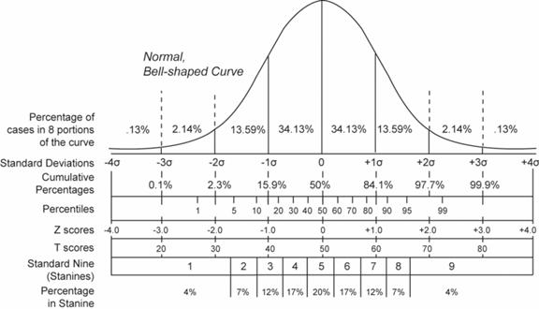Normal “Bell Curve”
Standard Form (variance of 1, mean of zero)
*Image Courtesy Wikipedia.org
The distinguishing characteristics of a bell curve distribution are that most of the population are clustered closely around the mean, or average, value, and comparatively few are scattered at the extremes (high or low). This middle-clustering leads to the bell-curve appearance; the highs and lows are the flange of the bell.
We see the bell curve around us in a million different things. If you measured the heights of all the people in your city, they’d probably match this distribution. That is, a tiny few would be super-abnormally short, a tiny few would be super-Yao Ming tall, and a great many would be within a few inches of the average.
The bell curve typically holds true whenever you are looking at people’s skill levels, too. Take sports - a tiny few are good enough to play professionally, a great many are good enough to get by, and a tiny few are so bad that they don’t get picked to be on teams (like me).

Other Distributions
The normal distribution, despite being swell, isn’t the only distribution around. It’s just amazingly common.
For examples of some additional distributions that are directly related to gaming and game design, just take a look the probability distributions of dice throws, in this case a d6 and then a 2d6 throw:
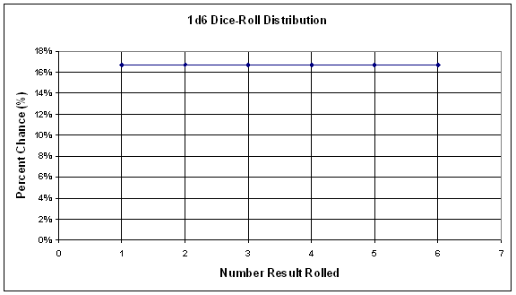
D6 Distribution

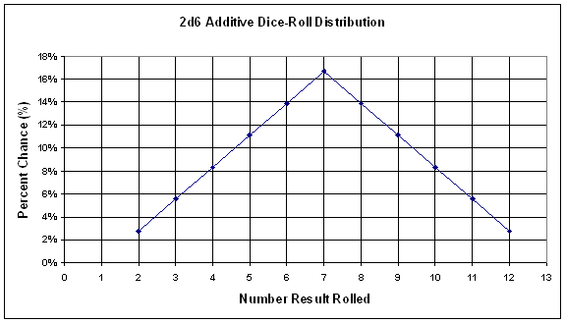
2d6 Distribution
In part 3 of this series, which should hit Gamasutra shelves around 2010, I’m going to spend a bunch more time talking about these dice distributions. For now, all I’m going to say is that the first one looks nothing like a bell curve, whereas the second throw is starting to resemble one (but still isn’t quite there yet).

Means to an End

"I'm MEAN!"
Consider this tiny section an intermission embedded within an otherwise tedious article. This tiny, self-referential section serves only one purpose in life: to remind you of what a “mean” is. This tiny, self-referential, and pedantic section would like to passively remind you that a mean is the mathematical average of a set of data.
This tiny, self-referential, pedantic, passive, and well-meaning section hopes that you take something meaningful away from reading it; for it is now that this tiny, self-referential, pedantic, passive, and pun-throwing paragraph must end.
Variance and Standard Deviation
Variance and standard deviation are very important to understand, and have a lot of tangible value. Aside from helping us draw valuable statistical conclusions, these terms enable us to speak a lot more intelligently about distributions. Instead of saying “a great many data points cluster about the middle”, we can say “68.2% of the sample falls within one standard deviation of the mean.” Chicks dig that speak; guys dig that speak; heck, who doesn’t dig that speak?
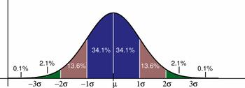
Normal Distribution with Standard Deviation Bars Shown
*Image Courtesy Wikipedia.org
Variance and standard deviation are related to each other, and they both measure the same thing: data scatter. Intuitively, a high variance or standard deviation means your data is all over the place. When I play darts, I get a high variance in my throws.
Variance and standard deviation can be easily calculated from any set of data that you have. I’d put the equations in here, but that would break my “don’t sound like a textbook” rule. So instead of an equation, here’s a description:
Standard Deviation: the average amount by which data points in the sample or population differ from the mean. Standard deviation is represented by the Greek letter σ (sigma)
In other words, say you test 100 people on how long it takes them to complete Level 1 in your newest game. Let’s assume the average (mean) of all the data is 2 minutes 30 seconds. Now assume the standard deviation calculates out to be 15 seconds. This standard deviation indicates that the grouping or “clumping” of the play sessions. In this case, it’s saying that on average, play sessions are within ±.25 minutes of 2.5 minutes. That’s pretty consistent.
What does this mean and why do you care? Easy. Pretend that instead of the above results, you got these results:
Mean = 2.5 minutes (same as above)
σ = 90 seconds = 1.5 minutes
So here we have the same mean but a vastly different standard deviation. This set of numbers means that you have much more scatter in the play times. On average, play times are about 90 seconds off of the mean play time. Given that the mean play time is only 2.5 minutes, that’s huge! And it’s probably not good to have that much scatter, for various game design reasons.
It would be much different if you were talking about a standard deviation of 90 seconds (1.5 minutes) on play times of 15 minutes.
Consistency is measured by a small standard deviation. Ratio your standard deviation against your mean to get a good warm-fuzzy number. In the first example, 15 sec / 150 sec = 10%. In the second, 90 sec / 150 sec = 60%. A standard deviation of 60% is bigggggg with indulgently repeated g’s. In the third, 90 sec / 900 sec = 10% again…respectable.
This is not to say that a large standard deviation is *always* bad. Sometimes as designers we want a large standard deviation in whatever we’re measuring. But a lot of times it’s bad, because it represents a lot of scatter and variability.
The important thing is that calculating standard deviation will tell you a lot about your game/mechanic/level/etc. Examples of useful things to measure standard deviation for:
- Level play times
- Whole-game play times
- Number of combat rounds it takes to defeat a typical enemy
- Number of coins collected (games with small Italian plumbers)
- Number of rings collected (games with fast, blue hedgehogs)
- Times controller is thrown at screen during your tutorial
Margins of Error
Margins of Error go hand in hand with statistical conclusions. Think of every Gallup Poll you’ve ever seen; there is always a margin of error expressed, such as ±2.0%. Because polls are using samples to estimate a population, there can never be 100% confidence (see later in the article). Margin of Err.0or indicates how accurate the results are. It is absolutely vital to know Margin of Error whenever you are talking about a population bigger than your sample.
If you take data on your entire population, then theoretically you don’t need a Margin of Error – you already know all the data! For example, if I ask everyone on my street whether they prefer Chess or Go, then I don’t need a Margin of Error as long as I am just reporting about people on my street. But if I want to draw a conclusion about everyone in my town based upon the data points from my street, then I have to calculate Margin of Error.
The bigger your sample size is, the smaller your Margin of Error. Mo data is bettuh.
(Self-)Confidence Intervals
You can use inferential statistics to draw conclusions about future data. One useful trick is the calculation of confidence intervals. Conceptually, confidence intervals are closely related to standard deviation, and are basically a mathematical way of saying how certain we are that a given piece of data will fall in a specified range.
Confidence interval: a mathematical way of saying “we can guarantee with A% confidence that B% of the data will be between values C and D.”
That’s a mouthful. But it’s useful to know, with a specified amount of confidence, what a value is likely to be. For a good example, I’m going to step back into my previous career for a blissful yet ultimately unsatisfying moment:

IMPORTANT: WINGS
MUST STAY ON!
I used to do stress analysis and design of aircraft bits and bobs. If you know, or need to know, anything about aircraft - and commercial aircraft in particular - it’s that it is the most regulated form of transportation that exists. People don’t like it when wings fall off of planes. ‘nuff said.
One of the methods we engineers use to keep said wings on said planes is designing to a very high confidence interval of material strength properties. A typical confidence interval used for aircraft design is the “A-basis allowable”, which means we are 95% confident that 99% of the values in any given shipment of a specified material fall above a certain value. Then, we design to that value against the worst possible air conditions, and then finally apply a big factor of safety on it. Gotta be sure.
Confidence intervals are very informative and useful whenever you *really want to know* what kind of data values to expect. Fortunately, games are not typically a matter of life and death, but if you are trying to balance an (unpatchable) console game, you probably want to have more than gut feel and intuition to go on. Calculating confidence intervals could be used to give you hard facts about how your game plays, and whether there are obvious exploits.
Whenever you want to calculate good confidence intervals, the ol’ standby rule of statistics still holds true: mo is bettuh. The more data points you have in your sample, the better your confidence interval calculation will be.
You Can Never Be Sure
This brings up another rule of statistics (and probability, actually):

The Customary Pose of Probablists and Statisticians
100% Does Not Exist: You will never achieve a confidence interval of 100%. You can never guarantee through inferential statistics that a predicted data point will be of a certain specified value.
The only sure things in life are death, taxes, and the inability to find the last Yeti Hide you need when trying to complete a World of Warcraft quest. Accept these facts and move on.
Misappropriation
I mentioned earlier that statistics works as a skill of villainy. To illustrate why, I wrote this short, bullet-form love poem:
Sonnet 1325: Beautiful statistics, let me count the ways that I abuse and misuse you.
- Misunderstanding
- Not stating confidence intervals
- Discarding valid conclusions because you don’t like them
- Drawing conclusions based upon flawed or influenced data
- Sportscaster errors – blending errors of probability and statistics
- Drawing conclusions based upon unrelated factors
Misunderstanding
People misunderstand statistical statements all the time. I know, it’s hard to believe.

Not Stating Confidence Intervals or Margins of Error
Confidence intervals and margins of error are vital pieces of information. There is a huge difference between saying 43% of PC owners have purchased a downloadable game in the past 30 days (Margin of Error 40%) and the same statement with a MoE of 2%. When MoE is left out, always assume the worst. Remember, small sample = high MoE.
Discarding Valid Conclusions Because You Don’t Like Them
When used properly, statistics don’t lie. But people lie to themselves all the time. We see this a lot in politics, where statistical studies will be ignored simply because the conclusions don’t match those that were hoped for. Same thing sometimes happens with focus groups. Of course, we also see statistics misused terribly in politics, so it’s a wash, I guess.
Drawing Conclusions Based Upon Flawed Data
This one happens a lot, especially in market research. Your statistical conclusions are only as good as the data you make them from. If the data is flawed, then the conclusions are worthless. Flawed data can come in a variety of forms, with causes ranging from honest errors to severe manipulation. Asking loaded questions is one easy way to get flawed data that supports whatever conclusion you were hoping to make anyway. “Do you prefer Product X, or that crappy Product Y that only idiots use?” quickly leads to seemingly bullet-proof statements like “95% of consumers prefer Product X!”
Sportscaster Errors

“Let me consult the oracle…”
Sportscasters are the shamans of our day. They take a little statistics, a little probability, a little gut feel and then mix them together to make something terrible. If you ever want to see a bunch of statistics thrown around with tenuous conclusions that typically have no basis, just watch a football game.
For instance, an announcer might say that “Team A hasn’t blocked a kick against Team B in the last 5 games.” The dangling conclusion is that Team A is less likely to block a kick than if they had done so in the last 5 games versus Team B. But you could say the same about the reverse--maybe they are more likely since they haven’t blocked one in a while!
The truth is, there isn’t enough information to say either one. And it’s probably more a matter of probability, anyway. Does the chance of blocking a kick really depend on whether one was blocked the game before? They are probably independent events, unless there are recognizable interrelated factors.
This is not to say that all sports conclusions are flawed. Statistics is very important to baseball, for instance. Statistical analysis sometimes guides what pitch is thrown or what the batting lineup will be.
It all comes down to data: when you have a lot of data, you get better statistical conclusions. Baseball supplies a lot of data: almost 200 games per season! With football, there almost just aren’t enough games to go around. Margins of Error are bigger. I’m not exactly saying statistics is never useful for football...it is just harder to mine useful, contextual data.

Drawing Conclusions Based Upon Unrelated Factors
People misunderstand statistical statements all the time. Rather, using compared relationships, it’s easy to infer deeper relationships that don’t actually exist. My all-time favorite example of this is the well-known Pirates vs. Global Warming graph featured in the CHURCH OF THE FLYING SPAGHETTI-MONSTER’S Open Letter to the Kansas School Board:
http://www.venganza.org/about/open-letter/
Please, for the love of all that is statistical, go look at the graph contained in that article. PLEASE, I BEG YOU!
Please, Can We Just Bookend the Quiz and Be Done?
Okay, okay, I hear you.
Q1a ANSWER – Level Times
The answer to this one is easy: you haven’t been given enough info to calculate the average yet. Just because the values ranged from 1:24 to 2:32 doesn’t mean they average out at 2 minutes. (Those two numbers average to 1.97 minutes, but we don’t know the other 18 results!) You need to know all 20 results to calc the average, and you really ought to calc the standard deviation as well...see below.
Q1b ANSWER – Level Times Part Deux
Okay, in this case you probably shouldn’t be satisfied because the standard deviation is pretty high...over 40% of the mean. This sounds like a bit too much variation in your level. There is potentially a sizable exploit that skilled players are using to their advantage. Alternatively, you might be punishing less-skilled players too much. As the game designer, you ultimately have to be the judge as to whether these results (high variation) are intended.
Q2 ANSWER – Soccer Moms
Stats only gets you part of the way there; you still need game design smarts. In this case, the score grouping is *way too close*...to have a standard deviation that low (500 / 52000 = 1%) means you are getting hardly any score variation, which means in turn that differences in player skill aren’t really mattering in the end game result. Therefore, players will most likely be turned off because they won’t see much of a progression in their scores as they get better at the game.
Here’s a situation where you’d really love to see a much higher standard deviation, because that hopefully shows that increased skill leads to increased scores. In other words, your current game scores the same no matter who plays it.
Q3 ANSWER – Play Times
This one is sorta tricky and underhanded but illustrates an important point about data collection: you need to watch out for obviously bad data. That one value, 0.2 hrs, looks suspiciously like an error. Could be a typo, could be an equipment malfunction, who knows. In any case, you should either convince yourself without a doubt that the 0.2 hrs is a valid data point before doing any calculations with it, or just throw it out and perform your calcs on the remaining data points.
Insert Other Cool Stuff Here
In efforts to keep this article under 723 pages, I have to skip over many other intriguing topics. Suffice it to say that a good understanding of statistics will help not only your game design, but your consumer decisions, voting decisions, and financial decisions. I’m 23.4% sure that at least 40% of what I just said is true.
As a designer, statistics is most useful when crunching data from a set of recorded play sessions (your sample), and trying to form conclusions about a larger field of unrecorded play sessions (your population).
Learn By Doing
For example, in the game I just finished, we recorded data from play sessions and then set challenge levels in the game based upon the mean and standard deviation values from those recorded data. We set Medium difficulty to be equal to the mean values, Easy difficulty to be equal to the mean minus a certain amount of standard deviations, and then Hard difficulty equal to the mean plus a certain amount of standard deviations. Had we collected much more data, it would’ve actually been accurate! <wink>
Just like probability theory, statistics becomes more and more useful the bigger and bigger the scope of your project. A lot of the time, you can fumble your way through without applying any formal theory in either case. But the bigger your game, the bigger your audience, and the bigger your budgets, then the more there is to risk from embedded flaws in an unbalanced, seat-of-the-pants designed game.
Stats, like probability, won’t do your game design work for you. It’ll just help you do it better!
The Long Road Ahead
In the rousing conclusion to this series, I’ll be taking bits from parts 1 and 2 and then putting them together in ways that actually have some relevance to games. Or I’ll croak trying!
Thanks for reading, and ciao for now.

Attributions:
*The Wikipedia images used in this article are licensed under the GNU Free Documentation License.

Assignment 3: Setting up Probabilities
A simple game situation and the desired outcome of the situation is given in “W4_ProbablityAssignment.pdf,” which is available in the Doc Sharing section. Please set up the probabilities for certain actions which will tend to achieve the outcome desired. Also analyze the role statistics plays in achieving desired outcomes.
Post the Probabilities document to this Discussion Area by Friday, February 6, 2009. Review and comment on the work of at least two other students by the end of the week. Post your comments to this Discussion Area.
Assignment 3 Grading Criteria | Maximum  Points
Established the probabilities accurately for the actions and the desired outcomes. | 8
Analyzed the role statistics plays in game designing. | 8
Posted well-formed conclusions and supported them with valid reasons. | 4
Total: | 20
For assistance with any problems you may have when completing this assignment—OR—to offer your assistance to classmates, please use the Problems and Solutions Discussion area located through the left side navigation link.

Assignment 4: Hit Point Charting
Use hit point charting for a given situation described in “W4_HitPointCharting.pdf,” which is available in the Doc Sharing area, to determine which of two equal forces will win a war game encounter if they adopt equal strategies.
Post the Hit Point Charting document to the appropriate Discussion Area and your sketches to the FTP by Friday, February 6, 2009. Review and comment on the work of at least two other students by the end of the week. Post your comments to the appropriate Discussion Area.
Assignment 4 Grading Criteria | Maximum  Points
Accurately applied the hit point charting to calculate the wining probabilities of the two teams. | 8
Provided the chart of their calculations and explained how they arrived at their conclusion. | 8
Displayed an understanding of the use and application of the concept for game development. | 12
Posted well-formed conclusions and supported them with valid reasons. | 4
Total: | 32
For assistance with any problems you may have when completing this assignment—OR—to offer your assistance to classmates, please use the Problems and Solutions Discussion area located through the left side navigation link.

Assignment 5: Final Project—Defining the Core Mechanics
Create a document defining part of the core mechanics of your Final Project. Identify at least one resource for your game. You should also include the following in your submission:
- The resource's source(s), including the rates of production and/or circumstances under which it appears
- The resource's drain(s), including the rates of consumption and/or circumstances under which it is consumed
- Any converters to other resources, including the rates of conversion between them
- Starting values for a sample level or situation
- Any significant equations that influence the economy
- The resource's role in defining the victory condition, if any (for example, largest number of points wins)
Post the Final Project file in .doc format to the appropriate Discussion Area and your sketches in .jpg or .gif format to the FTP by Sunday, February 8, 2009.
Assignment 5 Grading Criteria | Maximum  Points
Identified and defined at least one resource that will be used in the game. | 8
Correctly identified the source(s) and drain(s) for the resource. | 4
Correctly identified the converter(s) and defined the rates of conversion between the initial resource and the converted resource. | 4
Correctly defined the starting values for a sample level or situation. | 4
Included significant equation(s) that influence the economy. | 4
Correctly analyzed the resources' role in defining the victory condition. | 4
Total: | 28
For assistance with any problems you may have when completing this assignment—OR—to offer your assistance to classmates, please use the Problems and Solutions Discussion area located through the left side navigation link.

